**BY USING GAN GENERATING FAKE FACES**

Import necessary Libraries

import tensorflow as tf

import keras

from keras import layers

import numpy as np

import matplotlib.pyplot as plt

import cv2

import os

from tqdm import tqdm

import re

from keras.preprocessing.image import img_to_array

## Load data

def sorted_alphanumeric(data):

convert = lambda text: int(text) if text.isdigit() else text.lower()

alphanum_key = lambda key: [convert(c) for c **in** re.split('([0-9]+)',key)]

return sorted(data,key = alphanum_key)

*# defining the size of the image*

SIZE = 128

_img = []

path = '../input/face-mask-lite-dataset/without_mask'

files = os.listdir(path)

files = sorted_alphanumeric(files)

for i **in** tqdm(files):

if i == 'seed9090.png':

break

else:

img = cv2.imread(path + '/'+i,1)

*# open cv reads images in BGR format so we have to convert it to RGB*

img = cv2.cvtColor(img, cv2.COLOR_BGR2RGB)

*#resizing image*

img = cv2.resize(img, (SIZE, SIZE))

img = (img - 127.5) / 127.5

imh = img.astype(float)

_img.append(img_to_array(img))

91%|█████████ | 9090/10000 [07:55<00:47, 19.10it/s]

## Visailze our images

def plot_images(sqr = 5):

plt.figure(figsize = (10,10))

plt.title("Real Images",fontsize = 35)

for i **in** range(sqr * sqr):

plt.subplot(sqr,sqr,i+1)

plt.imshow(_img[i]*0.5 + 0.5 )

plt.xticks([])

plt.yticks([])

*# to plot images*

plot_images(6)

## 

Here, i have defined batch size so that these batches of images can be fed directly to the discriminator network.

batch_size = 32

dataset=tf.data.Dataset.from_tensor_slices(np.array(_img)).batch(batch_size)

# Generator

latent_dim = 100

def Generator():

model = tf.keras.Sequential()

model.add(layers.Dense(128*128*3, use_bias=False, input_shape=(latent_dim,)))

model.add(layers.Reshape((128,128,3)))

*# downsampling*

model.add(tf.keras.layers.Conv2D(128,4, strides=1, padding='same',kernel_initializer='he_normal', use_bias=False))

model.add(tf.keras.layers.Conv2D(128,4, strides=2, padding='same',kernel_initializer='he_normal', use_bias=False))

model.add(tf.keras.layers.BatchNormalization())

model.add(tf.keras.layers.LeakyReLU())

model.add(tf.keras.layers.Conv2D(256,4, strides=1, padding='same',kernel_initializer='he_normal', use_bias=False))

model.add(tf.keras.layers.Conv2D(256,4, strides=2, padding='same',kernel_initializer='he_normal', use_bias=False))

model.add(tf.keras.layers.BatchNormalization())

model.add(tf.keras.layers.LeakyReLU())

model.add(tf.keras.layers.Conv2DTranspose(512, 4, strides=1,padding='same',kernel_initializer='he_normal',use_bias=False))

model.add(tf.keras.layers.Conv2D(512,4, strides=2, padding='same',kernel_initializer='he_normal', use_bias=False))

model.add(tf.keras.layers.LeakyReLU())

*#upsampling*

model.add(tf.keras.layers.Conv2DTranspose(512, 4, strides=1,padding='same',kernel_initializer='he_normal',use_bias=False))

model.add(tf.keras.layers.Conv2DTranspose(512, 4, strides=2,padding='same',kernel_initializer='he_normal',use_bias=False))

model.add(tf.keras.layers.BatchNormalization())

model.add(tf.keras.layers.LeakyReLU())

model.add(tf.keras.layers.Conv2DTranspose(256, 4, strides=1,padding='same',kernel_initializer='he_normal',use_bias=False))

model.add(tf.keras.layers.Conv2DTranspose(256, 4, strides=2,padding='same',kernel_initializer='he_normal',use_bias=False))

model.add(tf.keras.layers.BatchNormalization())

model.add(tf.keras.layers.Conv2DTranspose(128, 4, strides=2,padding='same',kernel_initializer='he_normal',use_bias=False))

model.add(tf.keras.layers.Conv2DTranspose(128, 4, strides=1,padding='same',kernel_initializer='he_normal',use_bias=False))

model.add(tf.keras.layers.BatchNormalization())

model.add(tf.keras.layers.Conv2DTranspose(3,4,strides = 1, padding = 'same',activation = 'tanh'))

return model

generator = Generator()

generator.summary()

Model: "sequential"

_________________________________________________________________

Layer (type) Output Shape Param #

=================================================================

dense (Dense) (None, 49152) 4915200

_________________________________________________________________

reshape (Reshape) (None, 128, 128, 3) 0

_________________________________________________________________

conv2d (Conv2D) (None, 128, 128, 128) 6144

_________________________________________________________________

conv2d_1 (Conv2D) (None, 64, 64, 128) 262144

_________________________________________________________________

batch_normalization (BatchNo (None, 64, 64, 128) 512

_________________________________________________________________

leaky_re_lu (LeakyReLU) (None, 64, 64, 128) 0

_________________________________________________________________

conv2d_2 (Conv2D) (None, 64, 64, 256) 524288

_________________________________________________________________

conv2d_3 (Conv2D) (None, 32, 32, 256) 1048576

_________________________________________________________________

batch_normalization_1 (Batch (None, 32, 32, 256) 1024

_________________________________________________________________

leaky_re_lu_1 (LeakyReLU) (None, 32, 32, 256) 0

_________________________________________________________________

conv2d_transpose (Conv2DTran (None, 32, 32, 512) 2097152

_________________________________________________________________

conv2d_4 (Conv2D) (None, 16, 16, 512) 4194304

_________________________________________________________________

leaky_re_lu_2 (LeakyReLU) (None, 16, 16, 512) 0

_________________________________________________________________

conv2d_transpose_1 (Conv2DTr (None, 16, 16, 512) 4194304

_________________________________________________________________

conv2d_transpose_2 (Conv2DTr (None, 32, 32, 512) 4194304

_________________________________________________________________

batch_normalization_2 (Batch (None, 32, 32, 512) 2048

_________________________________________________________________

leaky_re_lu_3 (LeakyReLU) (None, 32, 32, 512) 0

_________________________________________________________________

conv2d_transpose_3 (Conv2DTr (None, 32, 32, 256) 2097152

_________________________________________________________________

conv2d_transpose_4 (Conv2DTr (None, 64, 64, 256) 1048576

_________________________________________________________________

batch_normalization_3 (Batch (None, 64, 64, 256) 1024

_________________________________________________________________

conv2d_transpose_5 (Conv2DTr (None, 128, 128, 128) 524288

_________________________________________________________________

conv2d_transpose_6 (Conv2DTr (None, 128, 128, 128) 262144

_________________________________________________________________

batch_normalization_4 (Batch (None, 128, 128, 128) 512

_________________________________________________________________

conv2d_transpose_7 (Conv2DTr (None, 128, 128, 3) 6147

=================================================================

Total params: 25,379,843

Trainable params: 25,377,283

Non-trainable params: 2,560

_________________________________________________________________

# Discriminator

def Discriminator():

model = tf.keras.models.Sequential()

model.add(tf.keras.layers.Input((SIZE, SIZE, 3)))

model.add(tf.keras.layers.Conv2D(128,4, strides=2, padding='same',kernel_initializer='he_normal', use_bias=False))

model.add(tf.keras.layers.BatchNormalization())

model.add(tf.keras.layers.LeakyReLU())

model.add(tf.keras.layers.Conv2D(128,4, strides=2, padding='same',kernel_initializer='he_normal', use_bias=False))

model.add(tf.keras.layers.BatchNormalization())

model.add(tf.keras.layers.LeakyReLU())

model.add(tf.keras.layers.Conv2D(256,4, strides=2, padding='same',kernel_initializer='he_normal', use_bias=False))

model.add(tf.keras.layers.BatchNormalization())

model.add(tf.keras.layers.LeakyReLU())

model.add(tf.keras.layers.Conv2D(256,4, strides=2, padding='same',kernel_initializer='he_normal', use_bias=False))

model.add(tf.keras.layers.BatchNormalization())

model.add(tf.keras.layers.LeakyReLU())

model.add(tf.keras.layers.Conv2D(512,4, strides=2, padding='same',kernel_initializer='he_normal', use_bias=False))

model.add(tf.keras.layers.LeakyReLU())

model.add(tf.keras.layers.Flatten())

model.add(tf.keras.layers.Dense(1,activation = 'sigmoid'))

return model

discriminator = Discriminator()

discriminator.summary()

Model: "sequential_1"

_________________________________________________________________

Layer (type) Output Shape Param #

=================================================================

conv2d_5 (Conv2D) (None, 64, 64, 128) 6144

_________________________________________________________________

batch_normalization_5 (Batch (None, 64, 64, 128) 512

_________________________________________________________________

leaky_re_lu_4 (LeakyReLU) (None, 64, 64, 128) 0

_________________________________________________________________

conv2d_6 (Conv2D) (None, 32, 32, 128) 262144

_________________________________________________________________

batch_normalization_6 (Batch (None, 32, 32, 128) 512

_________________________________________________________________

leaky_re_lu_5 (LeakyReLU) (None, 32, 32, 128) 0

_________________________________________________________________

conv2d_7 (Conv2D) (None, 16, 16, 256) 524288

_________________________________________________________________

batch_normalization_7 (Batch (None, 16, 16, 256) 1024

_________________________________________________________________

leaky_re_lu_6 (LeakyReLU) (None, 16, 16, 256) 0

_________________________________________________________________

conv2d_8 (Conv2D) (None, 8, 8, 256) 1048576

_________________________________________________________________

batch_normalization_8 (Batch (None, 8, 8, 256) 1024

_________________________________________________________________

leaky_re_lu_7 (LeakyReLU) (None, 8, 8, 256) 0

_________________________________________________________________

conv2d_9 (Conv2D) (None, 4, 4, 512) 2097152

_________________________________________________________________

leaky_re_lu_8 (LeakyReLU) (None, 4, 4, 512) 0

_________________________________________________________________

flatten (Flatten) (None, 8192) 0

_________________________________________________________________

dense_1 (Dense) (None, 1) 8193

=================================================================

Total params: 3,949,569

Trainable params: 3,948,033

Non-trainable params: 1,536

_________________________________________________________________

### plot image generated by generator before training

noise = np.random.normal(-1,1,(1,100))

img = generator(noise)

plt.imshow(img[0,:,:,0])

plt.show()

### Defining loss function and optimizer

optimizer = tf.keras.optimizers.RMSprop(

lr=.0001,

clipvalue=1.0,

decay=1e-8

)

cross_entropy = tf.keras.losses.BinaryCrossentropy(from_logits = True)

def generator_loss(fake_output):

return cross_entropy(tf.ones_like(fake_output),fake_output)

def discriminator_loss(fake_output, real_output):

fake_loss = cross_entropy(tf.zeros_like(fake_output),fake_output)

real_loss = cross_entropy(tf.ones_like(real_output),real_output)

return fake_loss + real_loss

### Defining training steps

def train_steps(images):

noise = np.random.normal(0,1,(batch_size,latent_dim))

with tf.GradientTape() as gen_tape , tf.GradientTape() as disc_tape:

generated_images = generator(noise)

fake_output = discriminator(generated_images)

real_output = discriminator(images)

gen_loss = generator_loss(fake_output)

dis_loss = discriminator_loss(fake_output, real_output)

gradient_of_generator = gen_tape.gradient(gen_loss, generator.trainable_variables)

gradient_of_discriminator = disc_tape.gradient(dis_loss, discriminator.trainable_variables)

optimizer.apply_gradients(zip(gradient_of_generator,generator.trainable_variables))

optimizer.apply_gradients(zip(gradient_of_discriminator, discriminator.trainable_variables))

loss = {'gen loss':gen_loss,

'disc loss': dis_loss}

return loss

## function to plot generated images

def plot_generated_images(square = 5, epochs = 0):

plt.figure(figsize = (10,10))

for i **in** range(square * square):

if epochs != 0:

if(i == square //2):

plt.title("Generated Image at Epoch:**{}\n**".format(epochs), fontsize = 32, color = 'black')

plt.subplot(square, square, i+1)

noise = np.random.normal(0,1,(1,latent_dim))

img = generator(noise)

plt.imshow(np.clip((img[0,...]+1)/2, 0, 1))

plt.xticks([])

plt.yticks([])

plt.grid()

import time

def train(epochs,dataset):

for epoch **in** range(epochs):

start = time.time()

print("**\n**Epoch : **{}**".format(epoch + 1))

for images **in** dataset:

loss = train_steps(images)

print(" Time:**{}**".format(np.round(time.time() - start),2))

print("Generator Loss: **{}** Discriminator Loss: **{}**".format(loss['gen loss'],loss['disc loss']))

## Training

train(5,dataset)

**OUTPUT**

plot_generated_images(1)

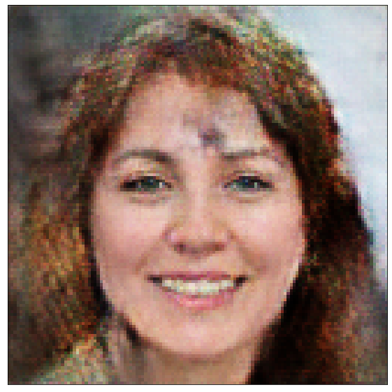

plot_generated_images(2)

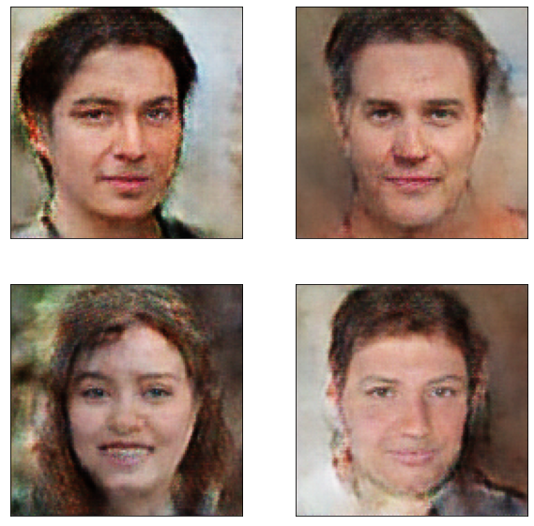

plot_generated_images(5)

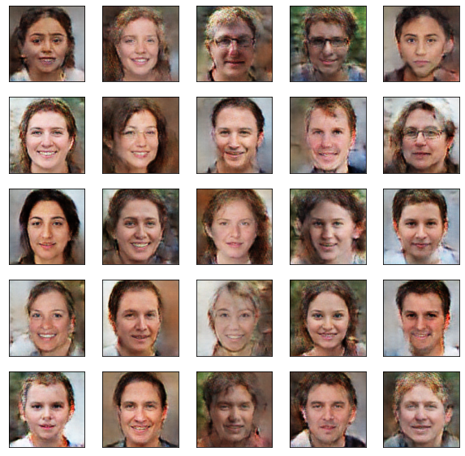

plot_generated_images(7)

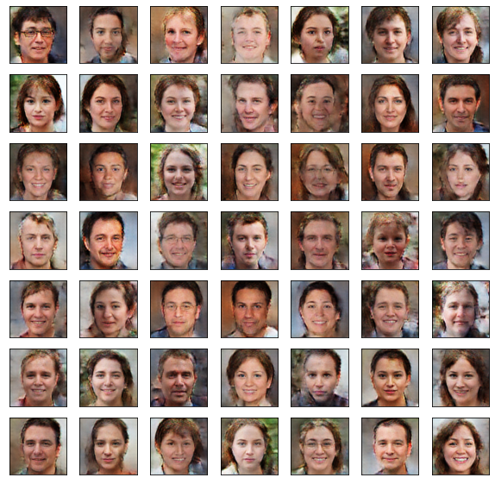  
generator.save('generator.h5')

discriminator.save("discriminator.h5")